PROJECT
AI-LAB
22f-3806

TASK 3
PROPOSITIONAL LOGIC:
import pygame
import time
from tkinter import Tk, Button
from pysat.solvers import Glucose3

# Constants
WIDTH = 600
HEIGHT = 600
GRID_SIZE = 9
CELL_SIZE = WIDTH // GRID_SIZE

# Colors
WHITE = (255, 255, 255)
BLACK = (0, 0, 0)
BLUE = (0, 0, 255)
LIGHT_GRAY = (200, 200, 200)

pygame.init()
win = pygame.display.set_mode((WIDTH, HEIGHT))
pygame.display.set_caption("Sudoku Solver (SAT-Based)")
font = pygame.font.SysFont(None, 40)

# Sample puzzle (0 = empty)
board = [
[0, 1, 0, 0, 4, 0, 0, 5, 0],
[4, 0, 7, 0, 0, 0, 6, 0, 2],
[8, 2, 0, 6, 0, 0, 0, 7, 4],
[0, 0, 0, 0, 1, 0, 5, 0, 0],
[5, 0, 0, 0, 0, 0, 0, 0, 3],
[0, 0, 4, 0, 5, 0, 0, 0, 0],
[9, 6, 0, 0, 0, 3, 0, 4, 5],
[3, 0, 5, 0, 0, 0, 8, 0, 1],
[0, 7, 0, 0, 2, 0, 0, 3, 0]
]

def varnum(i, j, d):
return 81 * (i - 1) + 9 * (j - 1) + d

def decode_var(var):
var -= 1
d = var % 9 + 1
j = (var // 9) % 9 + 1
i = var // 81 + 1
return i, j, d

def solve_sudoku(board):
solver = Glucose3()

# Cell constraints: each cell has at least one digit
for i in range(1, 10):
for j in range(1, 10):
solver.add_clause([varnum(i, j, d) for d in range(1, 10)])

# Cell uniqueness: at most one digit per cell
for i in range(1, 10):
for j in range(1, 10):
for d1 in range(1, 10):
for d2 in range(d1 + 1, 10):
solver.add_clause([-varnum(i, j, d1), -varnum(i, j, d2)])

# Row uniqueness
for i in range(1, 10):
for d in range(1, 10):
for j1 in range(1, 10):
for j2 in range(j1 + 1, 10):
solver.add_clause([-varnum(i, j1, d), -varnum(i, j2, d)])

# Column uniqueness
for j in range(1, 10):
for d in range(1, 10):
for i1 in range(1, 10):
for i2 in range(i1 + 1, 10):
solver.add_clause([-varnum(i1, j, d), -varnum(i2, j, d)])

# Box uniqueness
for bi in range(0, 3):
for bj in range(0, 3):
for d in range(1, 10):
cells = [(bi * 3 + i, bj * 3 + j) for i in range(1, 4) for j in range(1, 4)]
for idx1 in range(len(cells)):
for idx2 in range(idx1 + 1, len(cells)):
i1, j1 = cells[idx1]
i2, j2 = cells[idx2]
solver.add_clause([-varnum(i1, j1, d), -varnum(i2, j2, d)])

# Pre-filled values
for i in range(9):
for j in range(9):
if board[i][j] != 0:
solver.add_clause([varnum(i + 1, j + 1, board[i][j])])

if solver.solve():
model = solver.get_model()
for v in model:
if v > 0:
i, j, d = decode_var(v)
board[i - 1][j - 1] = d
return True
return False

def draw_grid():
for i in range(GRID_SIZE + 1):
width = 3 if i % 3 == 0 else 1
pygame.draw.line(win, BLACK, (0, i * CELL_SIZE), (WIDTH, i * CELL_SIZE), width)
pygame.draw.line(win, BLACK, (i * CELL_SIZE, 0), (i * CELL_SIZE, HEIGHT), width)

def draw_numbers():
for i in range(GRID_SIZE):
for j in range(GRID_SIZE):
if board[i][j] != 0:
text = font.render(str(board[i][j]), True, BLUE)
win.blit(text, (j * CELL_SIZE + 20, i * CELL_SIZE + 15))

def solve_and_draw():
start = time.time()
if solve_sudoku(board):
print("Solved in", round(time.time() - start, 2), "seconds")
redraw()
else:
print("No solution exists.")

def redraw():
win.fill(WHITE)
draw_grid()
draw_numbers()
pygame.display.update()

def start_gui():
root = Tk()
root.title("Sudoku Solver Control")
root.geometry("200x100")

solve_button = Button(root, text="Solve", command=solve_and_draw)
solve_button.pack(pady=20)

root.mainloop()

# Start GUI in a separate thread
import threading
threading.Thread(target=start_gui, daemon=True).start()

# Pygame loop
run = True
while run:
redraw()
for event in pygame.event.get():
if event.type == pygame.QUIT:
run = False

pygame.quit()
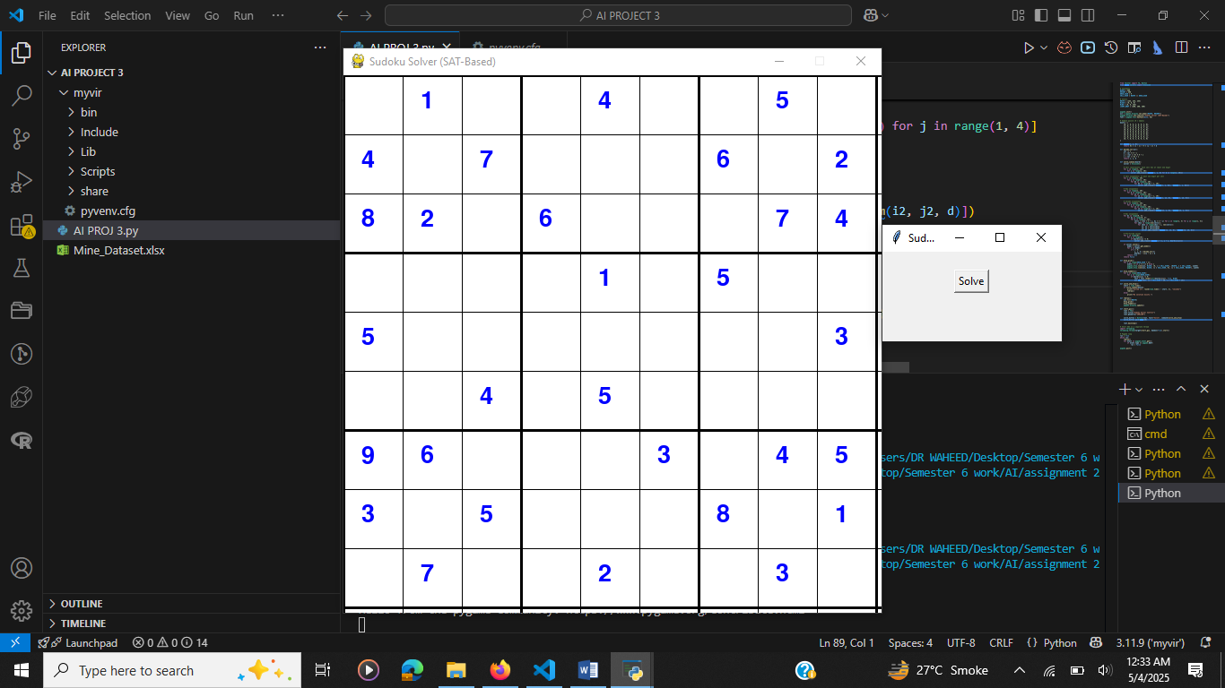
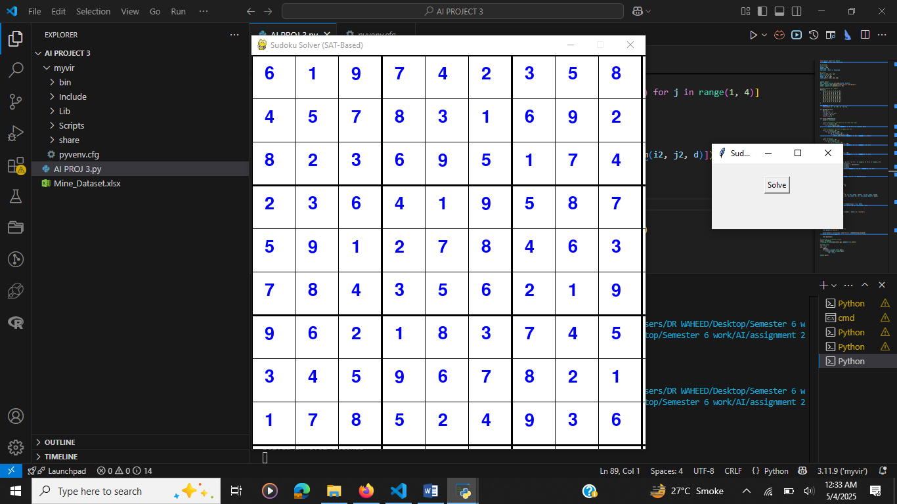

TASK 3
FIRST-ORDER LOGIC:
import pygame
from pygame.locals import *
from collections import defaultdict

# Initialize pygame
pygame.init()

WIDTH, HEIGHT = 540, 540
WIN = pygame.display.set_mode((WIDTH, HEIGHT))
pygame.display.set_caption("Sudoku with First-Order Logic")

FONT = pygame.font.SysFont("comicsans", 40)
BG_COLOR = (255, 255, 255)
LINE_COLOR = (0, 0, 0)
PRESET_COLOR = (0, 0, 0)
SOLVED_COLOR = (0, 128, 0) # Green for inferred numbers

board = [
[0, 1, 0, 0, 4, 0, 0, 5, 0],
[4, 0, 7, 0, 0, 0, 6, 0, 2],
[8, 2, 0, 6, 0, 0, 0, 7, 4],
[0, 0, 0, 0, 1, 0, 5, 0, 0],
[5, 0, 0, 0, 0, 0, 0, 0, 3],
[0, 0, 4, 0, 5, 0, 0, 0, 0],
[9, 6, 0, 0, 0, 3, 0, 4, 5],
[3, 0, 5, 0, 0, 0, 8, 0, 1],
[0, 7, 0, 0, 2, 0, 0, 3, 0]
]

original_cells = {(r, c) for r in range(9) for c in range(9) if board[r][c] != 0}

def draw_grid():
gap = WIDTH // 9
for i in range(10):
width = 4 if i % 3 == 0 else 1
pygame.draw.line(WIN, LINE_COLOR, (0, i * gap), (WIDTH, i * gap), width)
pygame.draw.line(WIN, LINE_COLOR, (i * gap, 0), (i * gap, HEIGHT), width)

def draw_board():
WIN.fill(BG_COLOR)
draw_grid()
gap = WIDTH // 9
for r in range(9):
for c in range(9):
if board[r][c] != 0:
color = PRESET_COLOR if (r, c) in original_cells else SOLVED_COLOR
text = FONT.render(str(board[r][c]), True, color)
WIN.blit(text, (c * gap + 20, r * gap + 10))
pygame.display.update()

def is_valid(b, r, c, num):
for i in range(9):
if b[r][i] == num or b[i][c] == num:
return False
box_x, box_y = 3 * (r // 3), 3 * (c // 3)
for i in range(box_x, box_x + 3):
for j in range(box_y, box_y + 3):
if b[i][j] == num:
return False
return True

def get_possible_values():
domain = defaultdict(set)
for r in range(9):
for c in range(9):
if board[r][c] == 0:
for n in range(1, 10):
if is_valid(board, r, c, n):
domain[(r, c)].add(n)
return domain

def solve_with_fol():
domain = get_possible_values()
if not domain:
return True

cell = min(domain, key=lambda x: len(domain[x]))
values = domain[cell]
if not values:
return False

r, c = cell
for val in values:
if is_valid(board, r, c, val):
board[r][c] = val
if solve_with_fol():
return True
board[r][c] = 0
return False

def main():
run = True
clock = pygame.time.Clock()

draw_board()
pygame.time.delay(1000)

solve_with_fol()
draw_board()

while run:
clock.tick(30)
for event in pygame.event.get():
if event.type == QUIT:
run = False

pygame.quit()

if __name__ == '__main__':
main()
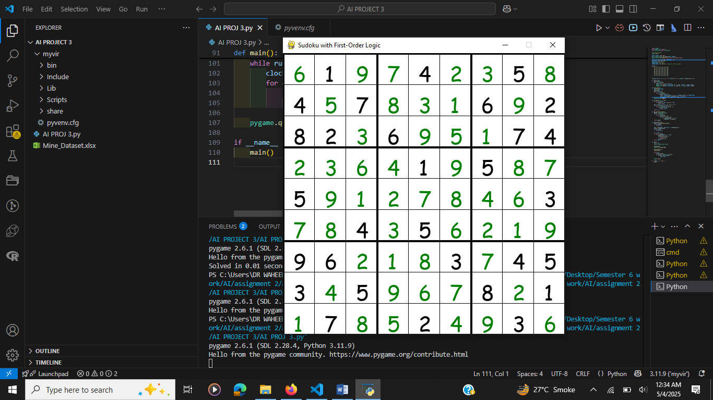

Summary
Feature | Propositional Logic Version | First-Order Logic Version
Library | python-sat | z3-solver
Representation | CNF clauses & SAT solving | Logical quantifiers & constraints
Model | Binary variables (cell, digit) | Integer grid variables
Readability | Low | High
Speed | Very fast | Fast and flexible

